

Quadrant Exercise

This exercise can be helpful in prioritizing work to be done. List the possible activities your institution is considering. Assign a ranking, from 1 to 4, with 1 being the lowest, for each activity to evaluate HOW WELL your institution does the activity and HOW IMPORTANT it is to your institution. Place the name/number of the activity in the quadrant below according to the ranking.

Activity | How Well | How Important
1.
2.
3.
4.
5.
6.
7.
8.
9.

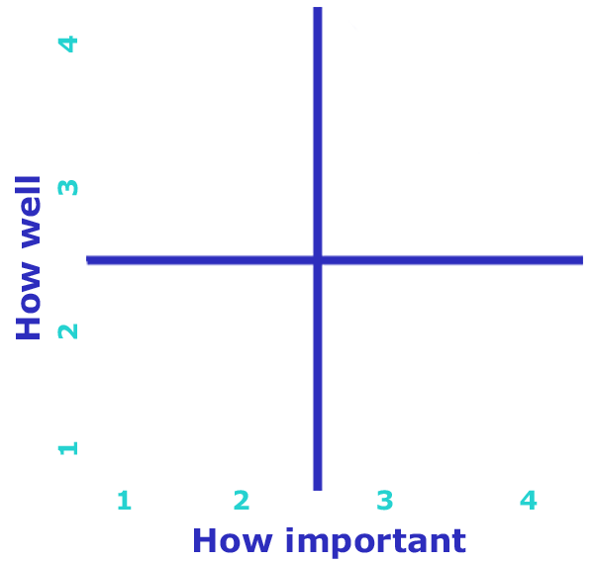

Your institution may want to focus on the activities that fall in the bottom right quadrant — those that are important but are not done well.

